THIS WEEK AT ST CHAD’S

TODAY 11.15am Holy Baptism
6.00pm Evening Prayer

MONDAY 9.30am Holy Eucharist
TUESDAY 6.00pm Holy Eucharist
at St Mary’s & St Peter’s

ASH WEDNESDAY
9.30am Holy Eucharist
7.30pm Sung Eucharist

THURSDAY St Sigfrid
7.00pm Holy Eucharist
FRIDAY 8.00am Holy Eucharist

NEXT SUNDAY:
THE FIRST SUNDAY OF LEN T
8.00am Holy Eucharist
9.30am SUNG EUCHARIST
6.00pm Service of Penitence

FOR OUR PRAYERS:
Sick: Jeanette, Julie Darke, Arthur Smith, Ann Galloway, Jackie Christie, George and Rita Bell, Ossie Braithwaite, Gordon and Carole Bennett

Died Recently: Ronald Lambert,
Joel Joseph Earl

Year’s Mind: Ella Thompson, Cecil Norman

SPRING COFFEE MORNING in the hall: Saturday 3 March 10.00am.
£2.50 inc Coffee and Hot Cross Bun.
Also Cakes & Craft Stalls and Raffle.

PROJECT GAMBIA 2017 On Sunday 11 March, we will have refreshments in the hall after the 9.30am Eucharist. Matthew Fowler will thank you for your support of Project Gambia, and will show pictures of his visit there with other students from Farringdon Community Academy last December.

BISHOP MARK will lead God with Us at Pallion on Sundays in Lent at 5.00pm. All welcome; details on poster.

SHROVE TUESDAY CHILDREN’S ACTIVITY AFTERNOON in St Thomas’ this Tuesday 1.00-3.00pm. All welcome, and anyone who’d like to help, too.

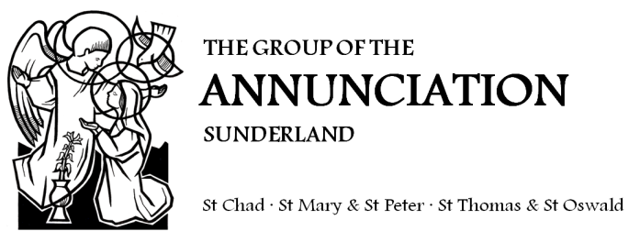
Welcome to
St Chad’s Church
Sunderland
www.stchad.co.uk

THE SUNDAY NEXT BEFORE LENT
11 February 2018

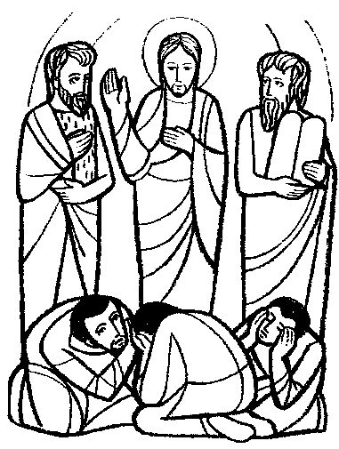

ASH WEDNESDAY: 14 February

the beginning of Lent.

9.30am Holy Eucharist

7.30pm Sung Eucharist

A day to worship together and begin Lent well.

THE LENT COURSE will be a new module of the ‘Pilgrim’ course we did a few years ago; this time focusing on The Creeds. Looking at the Nicene and Apostles’ Creeds, we’ll see how we can use them to grow in faith and live the Christian life and know God better. It will run on Mondays in Lent, 2.00pm and 7.30pm (with Eucharist at 1.30pm) in the vestry. We need to order a book for each participant (suggested donation £5) so please sign the list in church.

TODAY’S READINGS 2 Kings 2.1–12
2 Corinthians 4.3–6
Mark 9.2–9
HYMNS: C253, Psalm 148, C551, 663, 72, In Christ Alone
COLLECT: Almighty Father, whose Son was revealed in majesty before he suffered death upon the cross: give us grace to perceive his glory, that we may be strengthened to suffer with him, and be changed into his likeness, from glory to glory; who is alive and reigns with you and the Holy Spirit, one God, now and for ever.

PSALM 148
All the nations of the earth, praise the Lord, who brings to birth
The greatest star, the smallest flower: Alleluia

Let the heavens praise the Lord: Alleluia.
Moon and stars, praise the Lord: Alleluia.

Snow-capped mountains, praise the Lord: Alleluia.
Rolling hills, praise the Lord: Alleluia.

Deep sea water, praise the Lord: Alleluia.
Gentle rain, praise the Lord: Alleluia.

Roaring lion, praise the Lord: Alleluia.
Singing birds, praise the Lord: Alleluia.

Kings and princes, praise the Lord: Alleluia.
Young and old, praise the Lord: Alleluia.
Michael Cockett; © K Mayhew
NEXT SUNDAY IS THE FIRST SUNDAY OF LENT.
READINGS FOR NEXT SUNDAY :
FIRST READING Genesis 9.8–17
8 God said to Noah and to his sons with him,
9 ‘As for me,
I am establishing my covenant with you and your descendants after you,
10 and with every living creature that is with you,
the birds, the domestic animals,
and every animal of the earth with you,
as many as came out of the ark.
11 I establish my covenant with you,
that never again shall all flesh be cut off by the waters of a flood,
and never again shall there be a flood to destroy the earth.’
12 God said,
‘This is the sign of the covenant that I make between me and you
and every living creature that is with you,
for all future generations:
13 I have set my bow in the clouds,
and it shall be a sign of the covenant between me and the earth.
14 When I bring clouds over the earth and the bow is seen in the clouds,
15 I will remember my covenant
that is between me and you and every living creature of all flesh;
and the waters shall never again become a flood
to destroy all flesh.
16 When the bow is in the clouds,
I will see it
and remember the everlasting covenant between God
and every living creature of all flesh that is on the earth.’
17 God said to Noah,
‘This is the sign of the covenant
that I have established between me and all flesh that is on the earth.’

SECOND READING 1 Peter 3.18–22
18 Christ also suffered for sins once for all,
the righteous for the unrighteous,
in order to bring you to God.
He was put to death in the flesh,
but made alive in the spirit,
19 in which also he went and made a proclamation to the spirits in prison,
20 who in former times did not obey,
when God waited patiently in the days of Noah,
during the building of the ark,
in which a few, that is, eight persons,
were saved through water.
21 And baptism, which this prefigured, now saves you –
not as a removal of dirt from the body,
but as an appeal to God for a good conscience,
through the resurrection of Jesus Christ,
22 who has gone into heaven and is at the right hand of God,
with angels, authorities, and powers made subject to him.

GOSPEL Mark 1.9–15
9 In those days Jesus came from Nazareth of Galilee
and was baptized by John in the Jordan.
10 And just as he was coming up out of the water,
he saw the heavens torn apart
and the Spirit descending like a dove on him.
11 And a voice came from heaven,
‘You are my Son, the Beloved;
with you I am well pleased.’
12 And the Spirit immediately drove him out into the wilderness.
13 He was in the wilderness forty days,
tempted by Satan;
and he was with the wild beasts;
and the angels waited on him.
14 Now after John was arrested,
Jesus came to Galilee, proclaiming the good news of God,
15 and saying, ‘The time is fulfilled,
and the kingdom of God has come near;
repent,
and believe in the good news.’

